# Practical 9 Create an HTML page with External Style Sheet.

<html>

<head>

<link rel="stylesheet" type="text/css" href="9css.css"/>

</head>

<body>

<p> Kaustubh Wade (160410116050)</p>

<img src="desktop1.jpeg" alt="Image not found:(" height="200"; width="250"/>

<h1> Web Technology</h1>

</body>

</html>

## 9.1.css

p{ position:Absolute;

top:50px;

left:45px;

z-index:0;

}

img{ position:Absolute;

top:7em;

left:7em;

z-index:1;

}

h1{ position:Absolute;

top:5px;

left:5px;

z-index:2;

}

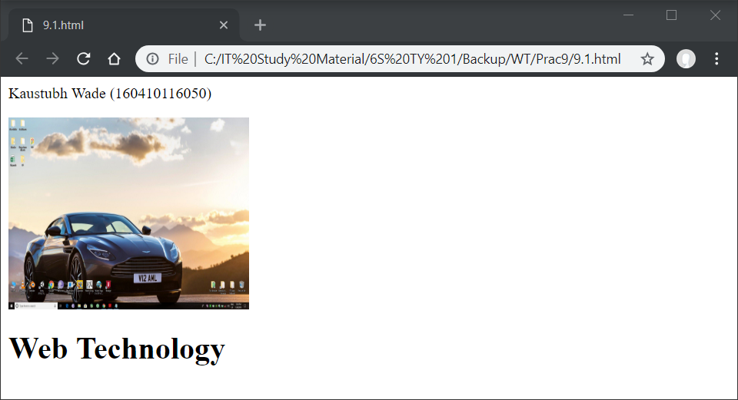

<html>

<head>

<link rel="stylesheet" type="text/css" href="9.2.css"/>

</head>

<body>

<p>Kaustubh Wade(160410116050)</p>

<br><br><br><br><br>

Web Technology

<br><br>

<br><br><br><br><br><br><br><br><br><br>

</body>

</html>

## 9.2.css

body{ color:maroon;

font-weight:400;

font-size:130%;

background-image:url("desktop2.jpg");

background-repeat:no-repeat;

background-attachment: fixed;

}

